Logistic Regression

Logistic regression is used when we have a categorical data (‘yes’,’no’,’true’,’false’,’0′,’1′,’positive’,’negative’), as in our below mentioned example where different ages people played a particular game and results are mentioned as ‘0’ for lose and ‘1’ for win.

import pandas as pd

df = pd.read_csv("abcde.csv")

df.head(10)

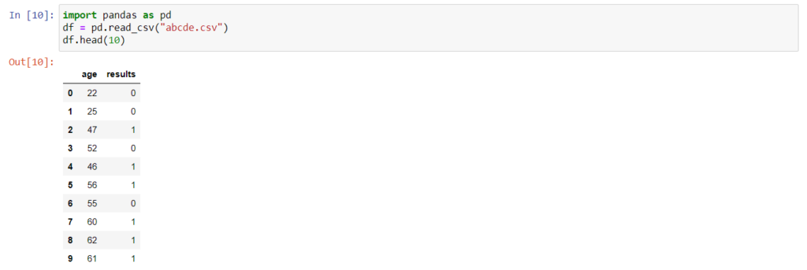

Now we need to split the data into training and testing data and for that we import train_test_split from sklearn.model_selection with a train size specified as 0.8 i.e. 80% of training data and remaining 20% would be testing data.

from sklearn.model_selection import train_test_split

X_train, X_test, y_train, y_test = train_test_split(df[['age']],df.results,train_size=0.8,random_state=10)

Then we import LogisticRegression from sklearn.linear_model and use *fit()* to train the model.

from sklearn.linear_model import LogisticRegression

model = LogisticRegression()

model.fit(X_train, y_train)

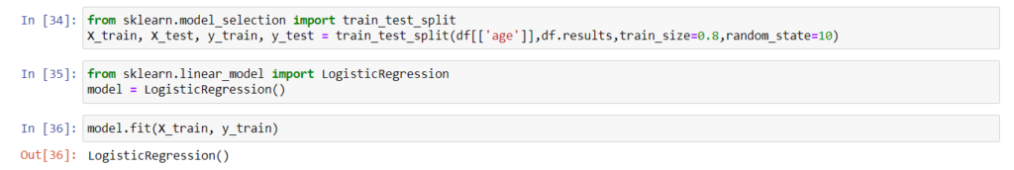

After the model is trained we try to predict by providing X_test values to model and model generates predictions as mentioned below.

y_predicted = model.predict(X_test)

y_predicted



model.score(X_test,y_test)

